**Jakob Holcomb and Nick Schnurr**

**Project Report**

**Projected Fantasy Points Vs. Actual Fantasy Points in NFL**

1. **Introduction**

Fantasy football has been a long-standing favorite for millions of fans for the National Football league (NFL). Friends, family, co-workers come together to become owners of their own team, and draft NFL football players. They compete against one another week by week throughout the entire NFL season. NFL players score various points based off catches, yards, and touchdowns scored. These fantasy owners must decide which player they want to start each week. They rely heavily on the projected points of each NFL player. Throughout the year, many of these projections are not accurately depicted in the individual football players’ actual performance. Our source written by *Fantasy Aftermath* has taken stats up to date to allow us to be as accurate with our conclusions as possible.

This analysis aims to explore the accuracy of fantasy football projections by comparing them to actual player performance over the course of the season. How accurate is the projected vs actual performance? How do touchdowns impact fantasy points scored? What stats impact fantasy points the most? Who are the top 10 fantasy players and what positions are in the top 10? We plan to answer all these questions in the report.

1. **Data**

The source we used to get the data is *Fantasy Aftermath.* This dataset had almost 18,000 inputs of data. We were going to use multiple sources but realized that the dataset had everything that we needed to complete our investigation. To get to the two data sources, we used the full 18,000 data points and then created another one showing the seasons from only 2019-2023, getting rid of the weeks. We felt this data source was efficient in helping us find our findings and having multiple areas of insight.

*2.1 Review Fantasy Points*

We wrote a script for this source to collect all the data across the specific week of play, the past 3 weeks, and seasons back to 2015.

The dataset was compiled into a CSV file. In our dataset of 18,000 entries, there were many players that don’t play and the projections for these players were 0. Which is why our dataset have multiple 0 inputs. There were also a lot of duplicate names and duplicate names on different teams (a player being traded). Splitting the data into only the seasons, we still faced duplicate names (ex. Multiple players were top performers from season to season). We wanted to include these duplicate names because they showed progression of the player throughout his career. but were able to see:

* The top performers through the past 5 years
* Which position had a bigger impact on fantasy points
* The correlation of fantasy stats compared to projected fantasy score

*2.2 Data Dictionary*

|  |  |  |
| --- | --- | --- |
| Column | Type | Description |
| Player | Text | The full Name of the player |
| Position | Text | The player's designated position (e.g., QB, RB, WR, etc.) |
| Team | Text | The team the specific player plays for |
| Fantasy Diff | Numeric | The difference from actual and projection fantasy points |
| Actual Fantasy Points | Numeric | Total points scored by the player in each week |
| Projected Fantasy Points | Numeric | Weekly and Season projections for expected performance |
| Pass Yards | Numeric | The number of pass yards the player has |
| Pass TDs | Numeric | The number of passing touchdowns the player has |
| Pass INTs | Numeric | The number of interceptions the players have |
| Rush Att | Numeric | The number of rushing attempts the player has |
| Rush Yards | Numeric | The number of rush yards the player has |
| Rush TDs | Numeric | The number of rushing touchdowns the player has |
| Rec Yards | Numeric | The number of receiving yards the player has |
| Rec TDs | Numeric | The number of receiving touchdowns the player has |

1. **Analysis**

*3.1 Actual Points vs. Projected Points*

This graph shows the relationship between **Actual Fantasy Points** (on the x-axis) and **Projected Fantasy Points** (on the y-axis). The red dashed line represents the "perfect" scenario where actual points match the projections. Each blue dot is a player, and we can see that most dots are clustered near the bottom left, meaning many players had low actual and projected points. However, the dots are spread out widely, showing that the projections often didn’t match reality. Some extreme outliers (like very high projected points) stand out and may indicate errors or unusual cases. Overall, the points don’t line up well with the red line, meaning the projections weren’t very accurate compared to the actual results.

*3.2 Distribution of Passing/Receiving Touchdowns*

This graph shows the distribution of rushing touchdowns compared to receiving touchdowns. As you can see, rushing touchdowns are more impactful than receiving touchdowns for fantasy. On a team, there are more receivers and tight ends that have a chance to score, rather than 1-2 running backs per team that have a chance to score. Running backs also have a better chance to score a receiving touchdown than a receiver scoring a rushing touchdown, which shows even further that rushing touchdowns are critical for a fantasy owner.

*3.3 Effect of Touchdowns on Points*

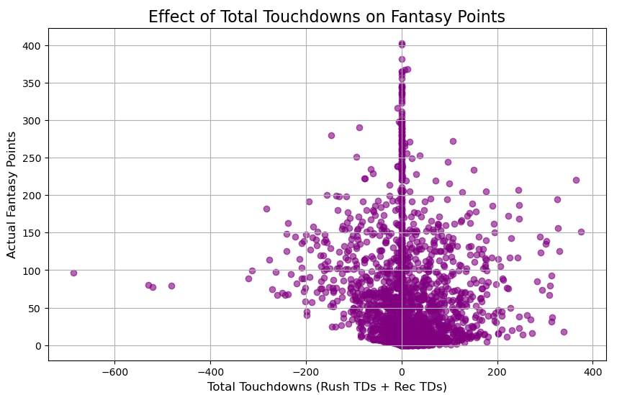

After comparing rushing vs receiving touchdowns, this graph is beneficial. This graph shows how impactful a touchdown can be for your fantasy team. A large cluster of points near 0 touchdowns suggests that many players contribute few or no touchdowns. The points with higher fantasy scores (approaching 400) are generally closer to positive touchdowns, reflecting that scoring more touchdowns tends to correlate with higher fantasy points. Based on some of the other data, quarterbacks are the highest-scoring position. They do not score touchdowns but gain a lot of passing and rushing yards.

*3.4 Top 10 Players*

This drive shows the impact QBs have on a fantasy team. 9/10 top performers on fantasy are QBs. Derrick Henry is almost 600 points behind Josh Allen. Josh Allen dominates fantasy, and Derrick Henry is a must-have for a fantasy team.

*3.5 Fantasy Statistic Impact*

This graph compares all the possible ways of scoring fantasy points. The most evident graph is passing touchdowns. This stat gives the least number of points in fantasy among touchdowns scored. There is a visible negative correlation between rushing and receiving touchdowns. Passing yards, on the other hand, have a great impact on the performance of QBs. Many of the points on this graph are 200 or more fantasy points. Showing why QBs perform the best on a fantasy team. The correlation between rush yards and receiving yards for actual fantasy points shows that rushing yards are more impactful for fantasy teams.

1. **Conclusion**

In this project our main goal was to find out how different fantasy projections were compared to actual fantasy points scored and while doing so we also gained relevant information to back up other questions we had while exploring this data. Below is our questions and results.

* 1. How accurate is projected fantasy points vs actual fantasy points?

When you look at some of the “star” players in the league who score the most points, it gets harder to project these points as seen in graph 3.1. As you move down to where players are scoring less fantasy points the projections are a lot closer to what these players are scoring.

* 1. How do touchdowns effect actual fantasy points scored?

Based on graphs 3.5 and 3.2, rushing touchdowns are the most impactful way for a touchdown to be scored. As stated above the correlation between rushing touchdowns and actual fantasy points scored, compared to passing and receiving touchdowns, has a greater positive impact. This is due to the fact that running backs are harder to come by than wide receivers, based on the simple ratio of how many running backs and wide receivers are on an NFL team. There are more wide receivers than there are wide receivers, which creates a bigger population to drag from.

* 1. Who are the top 10 fantasy players over the last 5 years? What positions are in the top 10?

Based off graph 3.4 the top fantasy players in the last 10 years are almost all QBs excluding the one running back in the top 10, Derrick Henry. According to our data QBs have dominated fantasy scoring and it looks like that will be the trend for some time to come. We found that Josh Allen, the QB for the Bills, is the highest scoring fantasy player in the last 5 years.

* 1. What fantasy stats have the greatest impact on actual fantasy points scored?

Pass yards and rushing touchdowns are the most impact stats to look at when looking at a fantasy team. Quarterbacks dominate fantasy in the aspect of scoring the most points. Running back touchdowns have the highest impact among touchdowns per correlation. Again, the population of running backs being lower than wide receivers shows the impact a good running back can have on actual points scored.

**Recommendations:**

We recommend for your future fantasy draft to target the high-scoring running backs and quarterbacks. These positions have the greatest impact on your actual points scored in your fantasy league. The population of wide receivers is too large, where you are able to pick multiple players from this position late in your draft and still end up with a solid player. For the foreseeable future, we can see that quarterbacks will continue to dominate the league in points, being that they touch the football every play. If you have the chance pick Derrick Henry and Josh Allen.

**Limitations:**

This project had many limitations that include narrowing down such a large data set and cleaning and refining the files that we wanted to use for our analysis, as well as the players that do not play and are projected 0 points which then effects the actual and projected points for players who typically score a lot of points. Taking credit from the all-star players that produce a lot for their individual positions. Some next steps would be to go deeper into the positions and how each position is scoring and being projected, analyzing different types of leagues (0, ½, and 1 point per reception), going deeper into the week-by-week projections and testing new data that is coming in during the season. After seeing new data coming in, we could add our own forecasting and projections and see how accurate we can get to the actual fantasy score.